**Tutorial 31: Two-way Data Binding – Keyboard Events & Modifiers**

In this tutorial we will be keeping track of the user’s skills by allowing a user to add new skills which we will store in the component data. We will be keyboard events such as key-up, key-down, etc.

Make sure **Tutorial 30** is complete to be able to move on to this tutorial or clone the [vue3-firebase-course](https://github.com/younggrasshopperza/vue3-firebase-course) repository and go to branch called **Tutorial-30** and navigate to the web-form folder.

**Step 1:** In the **Signup.vue** file, create a label and an input above the terms and condition (above div class of terms). The label will say skills. The input field will go directly below and have a type of text, a v-model called tempSkill. Create a data property called tempSkills with an empty string and create data property with an empty array.

Every time a user adds a new skill we will insert the data from tempSkill into an array and then we will clear the tempSkill when the data is added in the array.

Look at the example below (**Between line 17 and 18**):

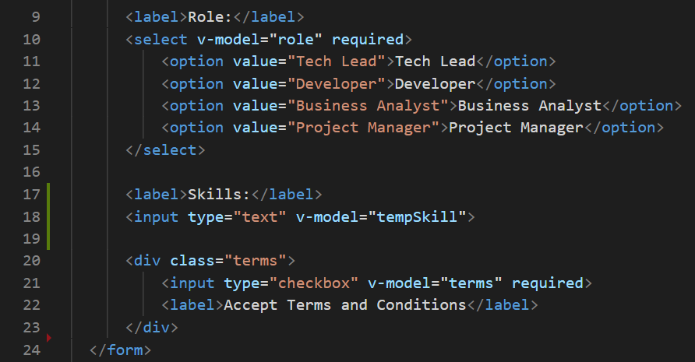

Look at the example below (**Between line 40 and 41**):

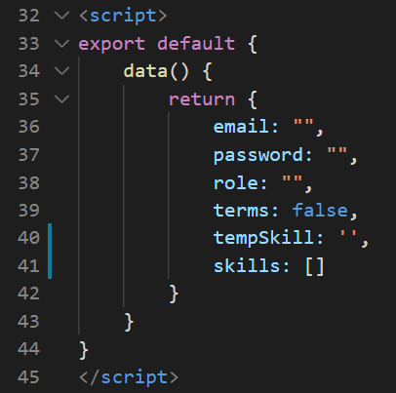

**Step 2:** In the **Signup.vue** file, we are going to listen for when the user types a comma so that we can add a new skill in an array.

Every time a user adds a new skill we will insert the data from tempSkill into an array and then we will clear the tempSkill when the data is added in the array.

In the skills input field add an event listener called key that takes the addSkills method.

Look at the example below (**Line 18**):

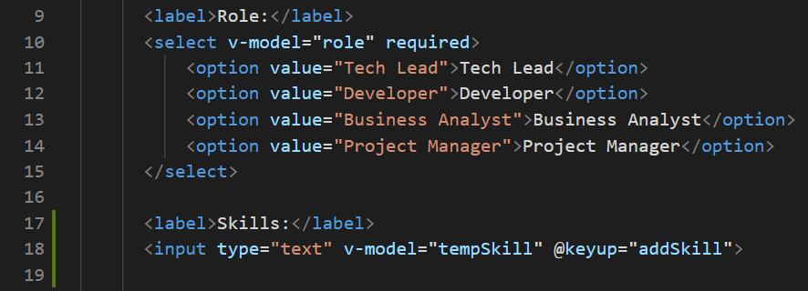

Create a method called addSkills in the methods property that takes an argument of e for the event object. Check if the event key has a comma and if the tempSkill is not an empty string. When the condition is true then add the skill to the array and make the tempSkill an empty string.

Look at the example below (**Between line 44 and 52**):

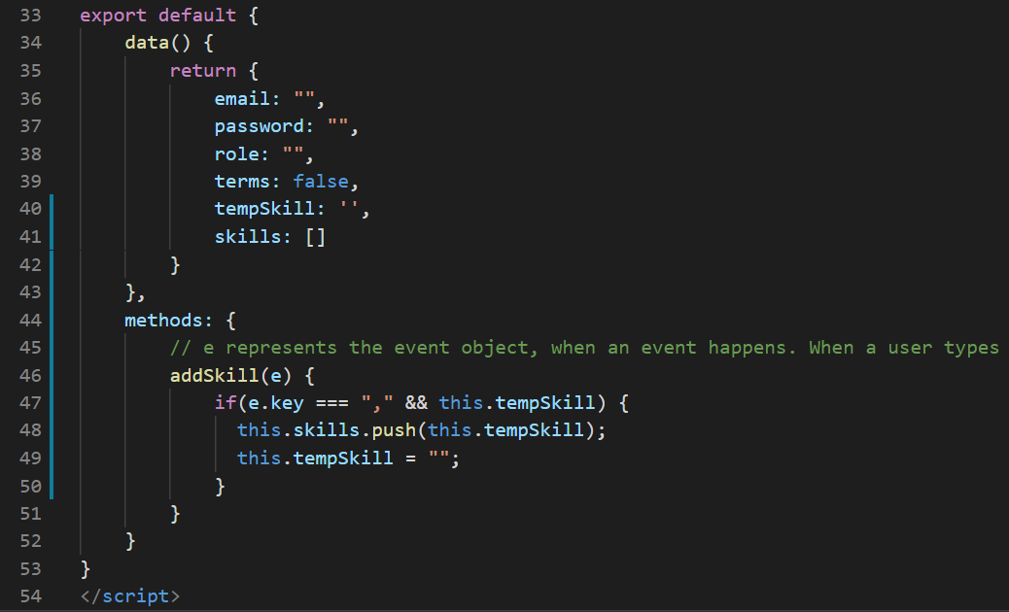

**Step 3:** In the **Signup.vue** file, under the skill input field add div that will loop and output each skill in the array. Add a class called pill.

Type a skill and add a comma.

**Output:**

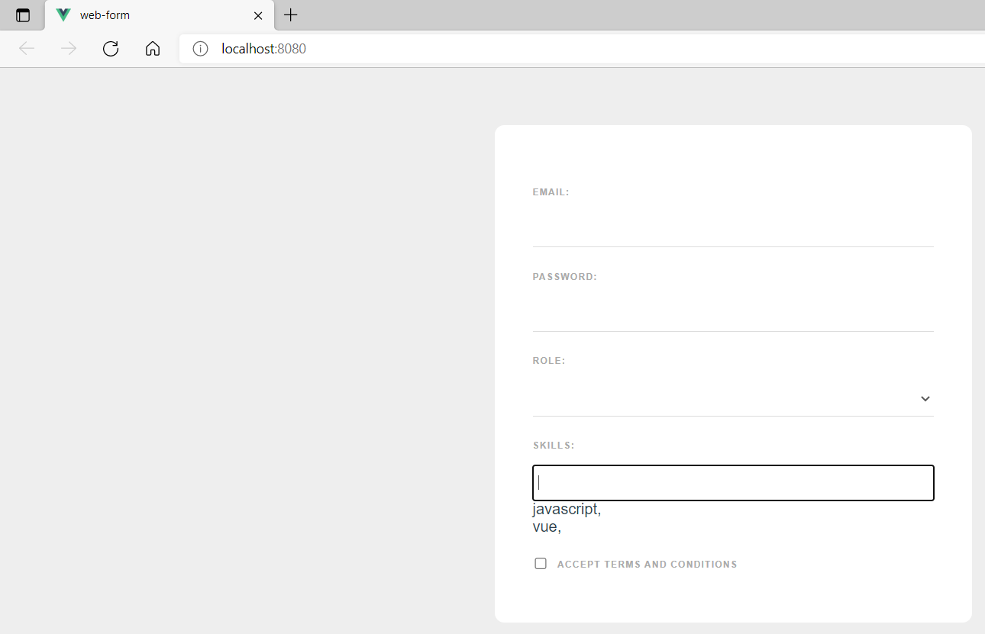

**Step 4:** In the **Signup.vue** file, we will remove the comma from the skills and avoid adding duplicate skills.

To avoid adding duplicate skills check whether the skills already exists in the array and if it does not then add the skill in the array.

Look at the example below (**Between line 52 and 56**):

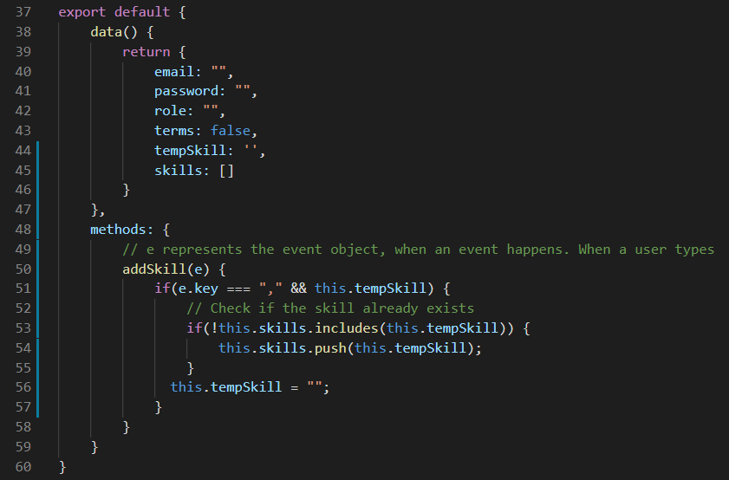

**Step 5:** In the **Signup.vue** file, add alt to the key event listener up.

Look at the example below (**Line 19**):

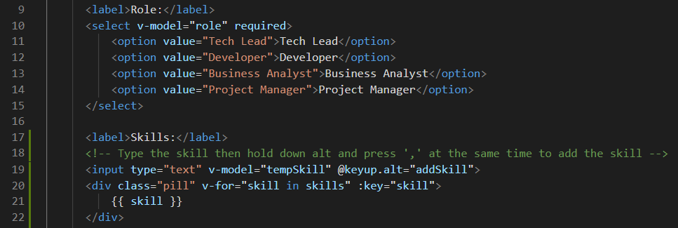

Type the skill then hold down alt and press ‘,’ at the same time to add the skill without the comma.

**Output:**

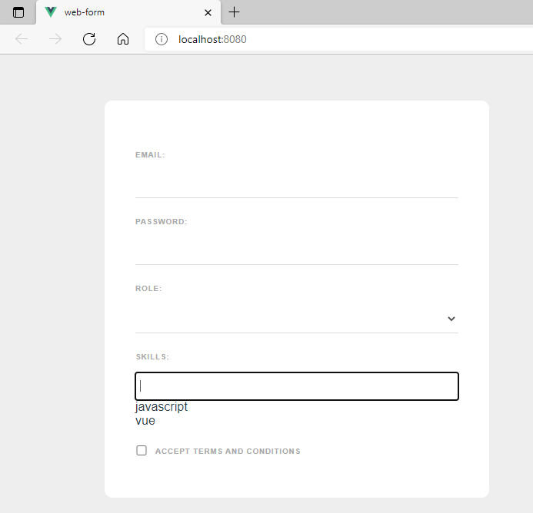

**Step 5:** In the **Signup.vue** file, add the following css code:

.pill {

  display: inline-block;

  margin: 20px 10px 0 0;

  padding: 6px 12px;

  background: #eee;

  border-radius: 20px;

  font-size: 12px;

  font-weight: bold;

  color: #777;

  cursor: pointer;

}

**Output:**

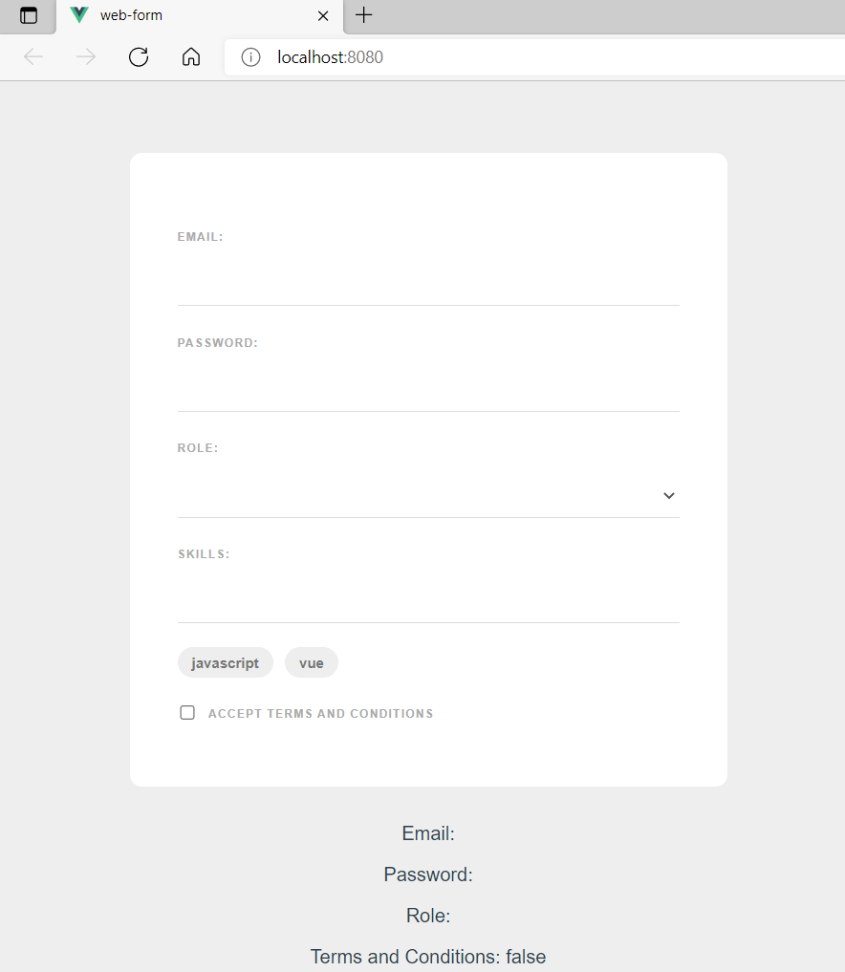

**You can view the code snippets from the** [**vue3-firebase-course**](https://github.com/younggrasshopperza/vue3-firebase-course) **repository under the Tutorial-31 branch**.